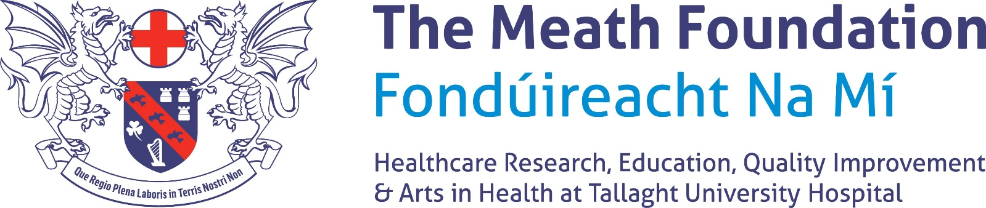

THE ELIZABETH O’DWYER MEDAL AND TRAVEL BURSARY FOR INNOVATION IN NURSING

2022 Application form

Name: __________________________________ Email Address: __________________________________
(Block letters)

Mobile Tel No: ___________________________ Grade: __________________________________________

Current position: _________________________ Department: _____________________________________

Title of the course/project: ___________________________________________________________________
(The title of the course/project should catch the reader’s attention and be accurate.)

Aims and objectives of the course/project:

Page 1 of 3

Summary of project:
(The summary of the project should be able to stand alone and include a clear rationale as to why the course/project will benefit safety and quality and thus the overall advancement of care/service to the patient. It should not exceed 150 words).

Title and summary of Research
- 2000 words only excluding references and abstracts. The applicant(s) should include a clear description of the aims and objectives of the project including the background and the relevance of the project and should include an implementation plan).
- If the application is for funding for education then the relevance of the course should be outlined and how this will benefit the service delivered to our patients.

Please use another page if required

Page 2 of 3

Personal statement:

I will ensure that The Meath Foundation's contribution to funding this research/education
is suitably acknowledged in any publications.
I will inform The Foundation of any changes to details set out in the application

Signature: ____________________________ Date: ________________________

The application must be sponsored by the Director of Nursing.

Signed: ________________________ Date: ________________________
Director of Nursing

Please return the completed application form by email to The Meath Foundation at

meath.foundation@tuh.ie

no later than

Thursday 30th June 2020

The decision of The Meath Foundation Board is final

2022

Page 3 of 3

