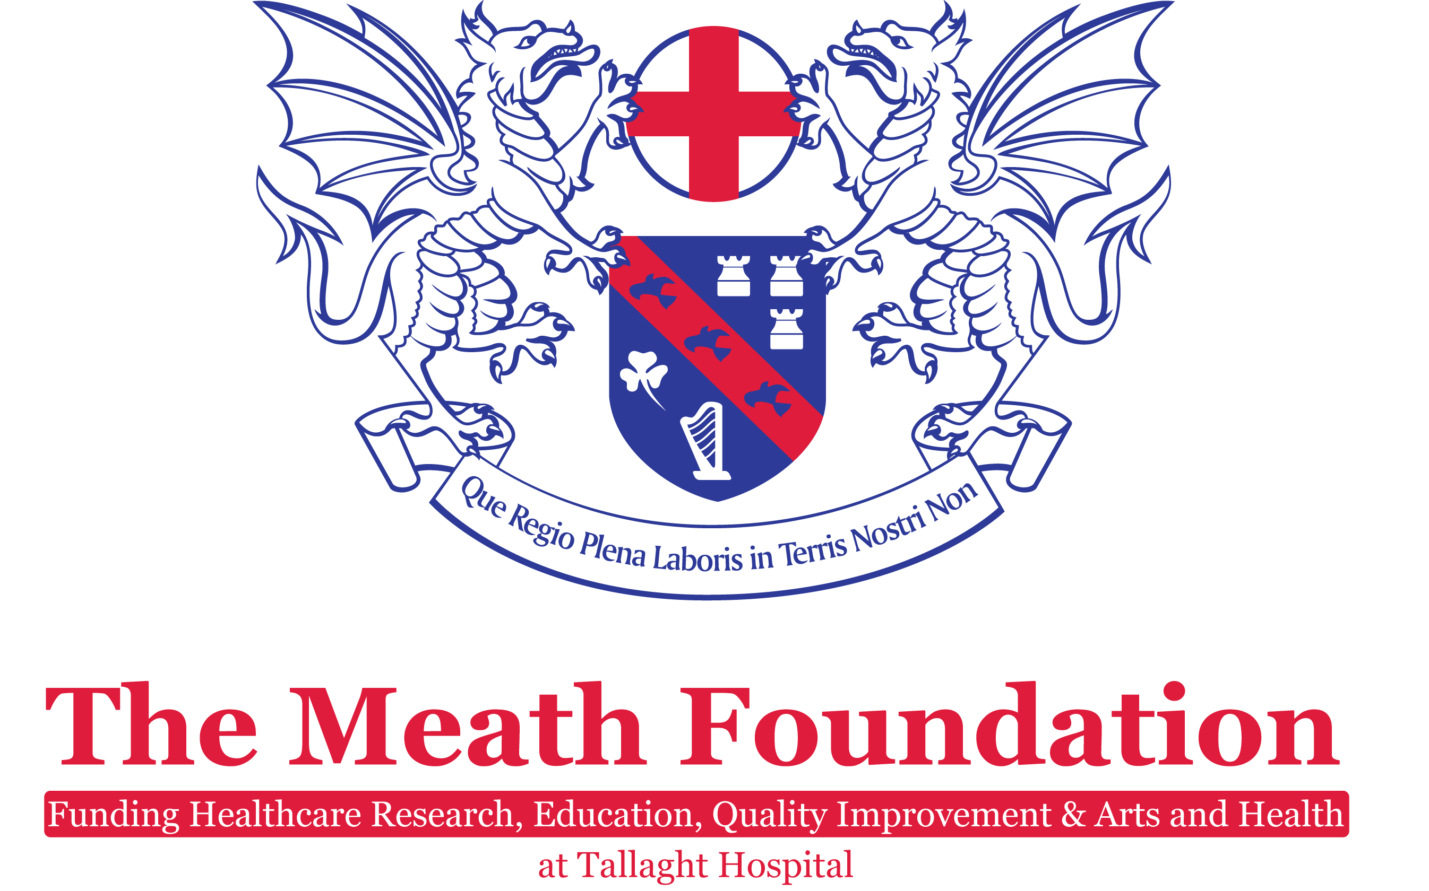

FUNDING PROGRAMME 2018
The Meath Foundation has announced over €500k to fund its programme for the coming year.

The Foundation is open for applications from all disciplines of staff for Research Grants, Fellowships and Quality Improvement Projects. In addition, Nursing Staff working in Emergency Medicine are invited to apply for the Mary O’Connor Research Medal & Travel Bursary. Clinicians, Nursing Staff and Healthcare Professionals are invited to apply for the J.A. Brian Keogh Research Medal & Travel Bursary.

Full details of funding available and how to apply can be found overleaf.

RESEARCH GRANTS
The applications period for the following Research Grants is currently open until 12pm Friday 9th March 2018. Application forms along with the Research Grant regulations are available at www.meathfoundation.com /research

- Two research grants up to €75,000
One of the above Research Grants is the John Barragry Research Grant
established to honour Dr. John Barragry, Consultant Endocrinologist for
his dedication to patient care in the Meath Hospital/Tallaght Hospital and
his contribution to the establishment and development of Tallaght Hospital
and The Meath Foundation

- Two Research Grants up to €50,000

- The inaugural Elizabeth O’Dwyer Research & Innovation Grant
This inaugural grant of up to €25,000 is being established to honour
Miss Elizabeth O’Dwyer, Former Matron/Director of Nursing at the Meath Hospital

THE MEATH FOUNDATION FELLOWSHIPS 2018
We welcome applications for the 2018 Meath Foundation Fellowships which are intended to fund innovative, ground-breaking projects that have the potential to advance knowledge or open a new approach to research.

The Meath Foundation Fellowship is a non-taught programme of independent research under an established supervisor that may lead or contribute to a higher degree. Funding will cover 12 month’s salary, or can be paid pro rata over a number of years

Applications are open to third level college graduates with a primary degree, medical or non-medical. The proposed Fellow and research programme must be supervised by an established investigator who should be based on the Tallaght Hospital Campus, Trinity College or another agreed recognised higher educational institution. The closing date for receipt of applications is 12pm Friday 9th March 2018. Application forms along with the Fellowship regulations are available at www.meathfoundation.com /Fellowships

QUALITY IMPROVEMENT
Is there something you would like to change in your area that would make a significant difference to the care of our patients? If the answer is yes, then The Meath Foundation would like to hear from you.
The Foundation established a Quality Improvement Fund in 2014 and provides funding to assist staff to introduce changes.
Funding available is for short-term (three – six months) projects up to a total of €15,000 and oriented towards the following:
- Consumable costs for the duration of the project
- Once off funding for software e.g. Licences
- Education & training
- Additional sessions for part-time staff or back fill for existing staff working on a Quality Improvement Project

Successful applicants will be offered training, support and mentoring from Mary Hickey, Quality Lead, Quality Safety & Risk Management Directorate. The closing date for receipt of applications is 12pm Friday 9th March 2018.Application forms along with the Quality Improvement Fund regulations are available at www.Meathfoundation.com/Quality improvement

AWARDS
The Mary O’Connor Research Medal & Travel Bursary
The Foundation welcomes applications from Nursing Staff working in Emergency Medicine for the 2018 Mary O’Connor award for Excellence in Emergency Medicine Nursing.

The Award was established to commemorate the late Mary O’Connor, a passionate, dedicated and innovative Nurse who was instrumental in developing the Emergency Department at Tallaght Hospital and, in particular, the Nursing Service. The successful applicant will be awarded the Mary O’Connor Research Medal and Travel Bursary in the amount of €500. Application forms along with further information on the Award are available at www.Meathfoundation.com/Mary O’Connor Award

J. A. Brian Keogh Research Medal & Travel Bursary
The Foundation welcomes applications for the 2018 J. A. Brian Keogh Award. The Award is open to all disciplines of staff and applicants are requested to submit a Nephrology based Abstract.
The award was established to mark the contribution made by Professor Keogh to the development of Renal Medicine during his career, both nationally and internationally, initially at the Meath Hospital and subsequently at Tallaght Hospital. The successful applicant will be awarded the J. A. Brian Keogh Research Medal and a Travel Bursary in the amount of €1,500. Application forms along with further information on the Award are available at:
www.Meathfoundation.com/J. A. Brian Keogh Award

The closing date for receipt of applications for these awards is 12pm Friday, 31st August 2018.

EDUCATION
The Meath Foundation Education Fund was established to assist staff who wished to obtain a Higher Degree. The Fund is co-managed with the Human Resources Directorate and funding is awarded on the basis that the successful applicant funds one third of the cost, the Hospital as the employer funds one third and The Foundation funds the balancing third.

Applications are welcome from all disciplines of staff and funding is awarded following a keenly competitive process.

Please note applicants for any of our Programmes must be members of staff and/or have a contractual commitment to work in Tallaght Hospital. For information on the application process please see the CLD prospectus or email. The applications for funding should be made through the Centre for Learning and Development. info.cld@amnch.ie for further information.

If you have any queries on the above programmes or would like further information, please drop into The Meath Foundation Office in the main atrium or email us on
Meathfoundation@amnch.ie or by telephoning 01-414 2432

The Meath Foundation
The Directors of The Meath Foundation include former staff of the Meath Hospital, staff of Tallaght Hospital and members of the local community. Membership of the Meath Foundation is open to all.

For a modest fee of €10 per annum you can help shape the future of The Foundation which has an impact on Tallaght Hospital, its patient’s, staff and the local community. If you would like to become a member of the Meath Foundation please provide your details below and return to the Foundation office with a subscription of €10. (Make cheques payable to the Meath Foundation, Tallaght Hospital, Tallaght, Dublin 24)

I wish to become a member of The Meath Foundation, subject to the Memorandum and Articles of Association of The Foundation and enclose herewith the stipulated annual contribution of €10

Name ……………………………………………………………………………………( Please print)

Address…………………………………………………………………………………( Please print)
……………………………………………………………………………………………….
………………………………………………………………………………………………

Telephone number………………

E-mail address……………………………………………

Signature ………………………………………………………Date…………………………………….

Contact person (Please supply name address and contact details).
……………………………………………………………………………………………………………
…………………………………………………………………………………………………………………
…………………………………………………………………………………………………………………

Application approved by the Board on the date of: …………………………………………..

Following five consecutive years as an annual member, an application may be made to become a Life Member of the Foundation for a once off fee of €50.

If you would like to more information on the working of The Meath Foundation please contact us on:

Tel: 01 414 2432 /414 5896

Email Meathfoundation@amnch.ie

Website at www.meathfoundation.com

